ACSL
American Computer Science League
2013 - 2014

Contest #4

Senior Division Solutions
1. 77
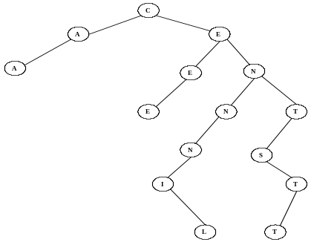
- Data Structures

The external path length is:
0*1+1*2+3*3+4*4+2*5+2*6+4*7
= 77

=2*5+

2. O
2. Data Structures The construction is as follows: B, BL, BLA, LA,
LAC, LACK, ACK, CK, CKC, KC, C, CA, CAN, AN, ANY, NY,
Y, YO, YON, ON. The next popped item is O since it is a queue.

. Di3. Digital Electronics The circuit translates to: 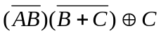
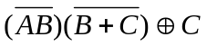=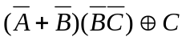=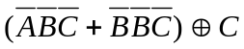=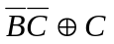
So 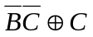=1. 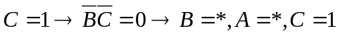 So (*, *, 1)
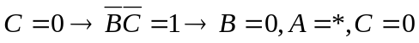 So (*, 0, 0)

3. (*, *, 1)
(*, 0, 0)

5. LISP

( CAR ( CAR ( REVERSE ‘( ( A B ) C ( ( D E ) F ) ) ) ) )
= ( CAR ( CAR ‘( ( ( D E ) F ) C (A B ) ) ) )
= ( CAR ‘( ( D E ) F ) )
= ( D E )

5. ( D E)

- Digital Electronics Circuit translates 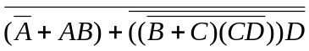
= 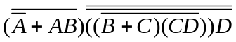= 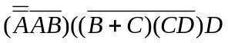
= 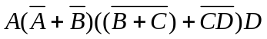= (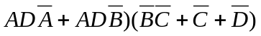
= 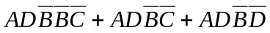= 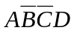
4. 